Discussion and conclusion
According to the results derived from tables 2, 3, and graph 1, it is concluded that the learning strategies application mean difference test is significant at the 0.05 level and with 95% certainty, it can be said that the amount of application of these strategies among students of different fields is not completely the same and the amount of their application in primary education students is significantly higher than their application in chemistry engineering students. According to Tukey certainty intervals table we can group the different fields based on the amount of learning strategies application in a way that English language and literature, business management, industry management, language teaching, and political science are gathered in one homogeneous group and primary education and chemistry engineering are placed in a completely heterogeneous group. in other words , the amount of learning strategies application in primary education field is more than other fields and in chemistry students is less than others.
Since the chemistry engineering field is different form other fields which are in humanity science group in regard to its education topic and difficulty coefficient, the obtained result is justifiable. As the primary education students have a course titled as a “new method of teaching-learning” and their other courses are also in some way related to learning methods, it is expected that they have a better ability in application of these skills than other student. Considering the graph, it is also understood that English teaching students have a higher mean than English Language and literature , business management , industry management and political science , although they are all in the same homogeneous group ,and it shows the positive effects of educational lessons on the amount of learning strategies application.
According to the results obtained from table 4 it is concluded that the learning strategies application mean differences test between successful and unsuccessful students is significant at the level 0.01 and so with 99% certainty we can say that the amount of application of these strategies in successful and unsuccessful students is completely different, it is significantly higher in successful students.
Based on the obtained results from tables 5 and 6, it can be concluded that the independence test was meaningful at the level 0.01 which shows the meaningful relation among the variables. In other words the amount of application of each skill is highly correlated with others and the total average of students. The regression process illustrated that anxiety overcoming and information processing skills variables have a substantial role in determining the total average variations , and it proves the importance of tranquillity and mental security and the amount of peace of mind in educational career and in the learning and educational performance. It is also understood that in the information processing field those students have a better performance who have the ability to comprehend and expand the information and are also able to relate new information to previously learned information.
Obtained results are compatible with previous similar studies such as Weinstein (1987), Chissom (1992), Keane (1993), Gadan (1994), Prus (1995), Gordon (1996), and Braten (1998).
Suggestion
Based on the findings of this study the following suggestions are given to improve the application of learning strategies among the students.
- The increase of learning strategies application among the students according the difference between the current situation and the desired situation is needed.
- Including one optional educational unit in all fields of studies in order to familiarize students with learning strategies.
- Presenting learning strategies familiarity periods for teachers and instructors of different fields.
- Equipping libraries and other university information enters with scientific books related to learning strategies.
- Advisors should emphasize on teaching learning strategies to the students as one of their important preferences.
- There should be some sessions with the presence of the educational instructors at the beginning weeks of each term to teach these strategies to the students.
- Some compulsory training classes should be held for both students and instructors to learn strategies.

Citations

Abdollahi, F. (2007). A comparison of the amount of study and learning strategies application by Successful and unsucessful students of Azad University, Sanandaj branch in 2005-2006 academic year. MA. Thesis, Sanandaj Islamic Azad university press: 85.

Braten, Ivar (1999) The learning and study strategies of Norwegian First- year college students. Learning and indivrdual differences, Vol. 10, No 4, PP 309-327.

Chissom B. Iranneejad A. Development of an instrument to assess learning strategies. Psycol Rep1992; 71:1001-2.

Gadan S. Underprepared students: Challenges facing college faculty .Michigan. Eric ed;1994

Gordon WI. (1996) A factor analytic study of the self – regulated learning inventory. Annual Meeting of the American Educational Reseurch Association. New York.

Haught, Patricia, Hill, Lee, Ann, Walls, Richard t.: Journal of first- year Experience, Vol 10, No 2, p.p 25-40.

Keane M. Prefered learning styles and study strategies in a linguistically diverse bachularate nursing student population. J Nurs Educ 1993;32(5):214 -21.

Khadivzadeh,T.Seif.A.A, and Valaei, N.(2002). A survay on study and learning strategies and the student educational achievment at mashhad medical sciences university. Beheshti medical sciences magazine. 7(1) English reference, P 41.

Mayo, K.E. Learning strategy instruction: Eypioring the potential of metacognition. Reading improvement: 30(3), p.p130-133.

Prus J, Hatcher L ,Hope M .et al. (1995) The learning and study strategies inventory as a predictor of first year college academic success. J Freshman Year Experience.7 (2).7-26.

Seif. A. A. (1992): Educational psychology (Learning and teaching psychology), Tehran, Agah Publications, P 281.

Seif. A. A. (2006): Learning and study methods.Tehran,Doran Publication, P 73.

Shariatmadari.A: (1997).Rules and Principles of education philosophy,Tehran :Amir Kabir Publications, P23.

Michele, Simpson (1994). Learning styles and study strategies population. J Nurs Educ: 30 pp210-214.

Weinstein CE. LASSI User's manual. FL:H&H Publishing company Inc. 1987.
Table1: Population

Field |  | English literature | Business management | Industrial management | English teaching | chemistry engineering | political science | primary education | Total
Number of  Students | Total | 16 | 247 | 175 | 127 | 282 | 185 | 95 | 1127
Number of  Students | Successful | 3 | 40 | 28 | 20 | 46 | 30 | 16 | 183
Number of  Students | Unsuccessful | 3 | 40 | 28 | 20 | 46 | 30 | 16 | 183

Table 2. One-way ANOVA to compare the amount of learning strategies application among the students of different fields

 | Sum of Squares | df | Mean square | F | Sig.
Between Groups  Within Groups  Total | 19198.30 | 6 | 3199.717 | 2.165 | 0.036
Between Groups  Within Groups  Total | 492118.3 | 333 | 1477.833
Between Groups  Within Groups  Total | 511316.6 | 339

Table 3. Tukey’s Confidence Intervals

Field (1) | Field (2) | Mean Difference | Sig. | 95% Confidence Interval
 |  |  |  | Lower Bound | Upper Bound
English literature | Business management  Industrial management  English teaching  chemistry engineering  political science  primary education | -1.37  -.88  -3.22  9.51  4.2  -17.32 | 1  1  1  0.997  1  0.951 | -49.88  -50.26  -53.14  -38.54  -44.97  -68.06 | 47.14  48.51  46.71  57.56  53.37  33.14
Business management | Industrial management  English teaching  chemistry engineering  political science  primary education | 0.49  -1.85  10.87  5.57  -15.96 | 1  1  0.560  0.986  0.452 | -20.88  -24.45  -7.21  -15.31  -40.29 | 21.86  20.75  28.96  26.44  8.38
Industrial management | English teaching  chemistry engineering  political science  primary education | -2.34  10.38  5.07  -16.45 | 1  0.735  0.995  0.499 | -26.76  -9.92  -17.75  -42.47 | 22.07  30.69  27.90  9.58
English teaching | chemistry engineering  political science  primary education | 12.72  7.42  -14.11 | 0.584  0.970  0.716 | -8.87  -16.57  -41.15 | 34.32  31.40  12.94
chemistry engineering | political science  primary education | -5.31  -26.83 | 0.985  0.013 * | -25.09  -50.23 | 14.48  -3.43
political science | primary education | -21.52 | 0.166 | -47.14 | 4.10

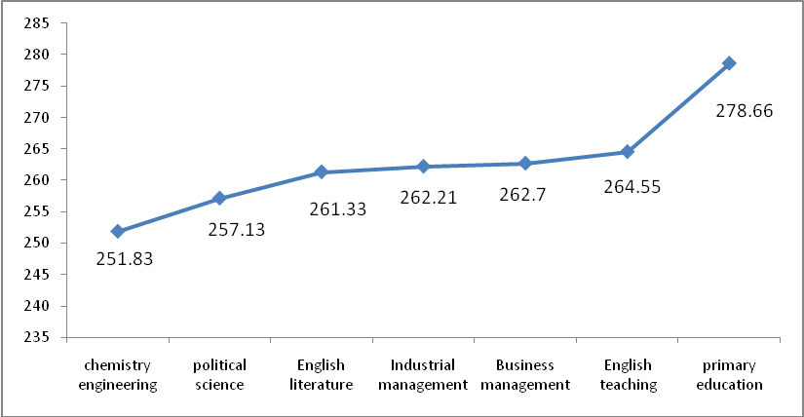
Graph1. The mean of learning Strategies application in different fields
Table 4. T-test to determine the mean difference in the application of learning strategies in successful and unsuccessful students
Table 5. correlation coefficient among learning strategies and average
